**Controller.**

1. **First stage.**

Initially, since we are new in the converter control techniques and integrated circuits we are planning to use simpler controller while starting the project. For that purpose, we choose the “FAN 6604” IC. It has 6 pins and various features like built in soft-starting and current mode control. Also, its pwm frequency is very close to the one that we determined before therefore, we can use the all of out ratings with that controller.

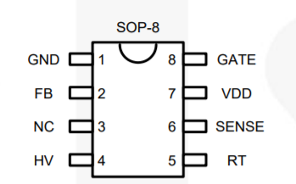

Figure XX: pin diagram.

FB pin still needs compensation network to determine performance of the controller. Gate pin is the output of that controller which is connected to “gate” of the power mosfet. Also, from the “SENSE” input we can give peak current feedback from the output of the converter and by this way the current mode control can be done. Additionally, HV pin provides soft starting by keeping PWM at very low values until its internal charges become full. However,

1. **Second stage**

In order to regulate the output voltage we need to implement some kind of feedback. In order to implement controller, if we are successful at first stage,we are planning to use “UCC28780” integrated circuit .Beside providing PWM control feature for regulation purposes, it has multiple features that satisfy the requirements of the project. For example,it provides synchronous switching for active clamp snubber configuration which reverse the energy of the leakage winding to the source.

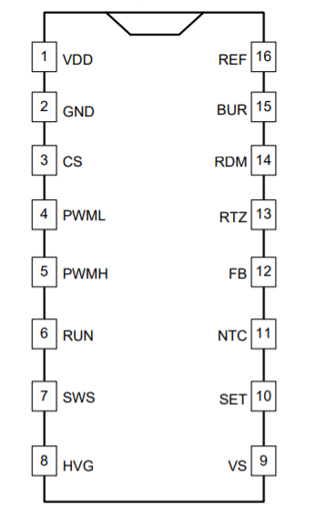

*Figure xx: Pin diagram of UCC28780.*

In order implement this operation pin 4 and pin 5 should be connected to the high side and low side gate drivers of the mosfets. Also, it can provide soft starting through the current sense input (pin 7). And another important feature of it is current mode control.